The Role of Explainable AI (XAI) in Data Analytics for Financial Decision-Making
Kirtan Patel
Department of Computer Science & Engineering (CSPIT)
CHARUSAT
Nadiad, India
23cs067@charusat.edu.in
Jigar Sarda
Department of Computer Science & Engineering (CSPIT)
CHARUSAT
Nadiad, India
jigarsarda.ee@charusat.ac.in
Amit Thakkar
Department Computer Science & Engineering (CSPIT)
CHARUSAT
Nadiad, India
amitthakkar.it@charusat.ac.in

Abstract — Automated credit decisioning (loan approvals, credit limits, and debt-collection prioritization) relies increasingly on machine learning models that can process high-dimensional customer data. While modern models often offer improved predictive accuracy, many act as black boxes and raise concerns about transparency, auditability, and fairness. This paper presents a reproducible Explainable AI (XAI) pipeline for credit default prediction using the UCI Credit Card Default dataset (30,000 anonymized records). We compare a transparent baseline (Logistic Regression) with a hyperparameter-tuned Random Forest and demonstrate a layered XAI approach comprising SHAP (global and local), LIME (instance explanations), Partial Dependence and ICE plots, permutation importance, calibration analysis, fairness auditing, and UMAP visualization. Our Random Forest achieves ROC-AUC = 0.7743 on a held-out test set (6,000 samples). We show how layered XAI uncovers the drivers of risk (e.g., repayment-status features) and surfaces calibration and subgroup disparities that are important for operational deployment. We release reproducible artifacts (preprocessor, trained models, explainers, and figures) to support verification and auditing.
Keywords— Explainable AI · Credit Default Prediction · SHAP · LIME · Random Forest · Financial Risk Management · Fairness · Calibration · UMAP.

Introduction
Financial institutions increasingly rely on automated decision-support systems to assess creditworthiness, manage risk, and improve operational efficiency. Activities such as loan approvals, credit limit assignment, and collection prioritization are now commonly supported by machine learning models trained on large volumes of customer data. While these systems offer clear advantages in scalability and predictive accuracy, they also raise important concerns regarding transparency, accountability, and fairness. Credit decisions have a direct impact on individuals’ financial opportunities, making it essential that automated systems are not only accurate but also interpretable and auditable [2, 7].
Traditionally, credit scoring has relied on linear and rule-based models, particularly logistic regression and scorecard approaches, due to their simplicity and ease of explanation [2]. These models allow practitioners to directly inspect feature coefficients and understand how individual variables influence risk predictions. However, as financial datasets have grown in size and complexity, more expressive models such as Random Forests and gradient-boosted trees have become increasingly popular because of their superior performance on structured tabular data. Despite their effectiveness, these models are often viewed as “black boxes,” which limits their acceptance in regulated environments where decision rationale must be clearly communicated to auditors, regulators, and customers [14,17]
Explainable Artificial Intelligence (XAI) has emerged as a promising approach to address this trade-off between predictive power and interpretability. XAI techniques aim to provide meaningful explanations of model behavior at both global and local levels. Global explanations describe overall patterns learned from the data, while local explanations justify individual predictions [6]. Methods such as SHAP and LIME enable post-hoc interpretation of complex models, and visualization and diagnostic tools support deeper analysis of feature effects, probability calibration, and subgroup performance. In financial applications, these capabilities are particularly important for regulatory compliance, responsible deployment, and building trust among stakeholders [3,4].
Although recent studies have examined explainability, fairness, or predictive performance independently, relatively few works present an integrated and reproducible framework that addresses these aspects simultaneously within a single credit risk pipeline. Operational considerations such as calibration quality, subgroup disparities, and cohort-level visualization are often treated as secondary, despite their importance in real-world deployment. [7,8,9,10]
This paper proposes a unified Explainable AI pipeline for credit default prediction using the publicly available UCI Credit Card dataset. The framework combines an interpretable logistic regression baseline with a hyperparameter-tuned Random Forest model to balance transparency and predictive accuracy. A layered explainability strategy is adopted, incorporating SHAP for global and local feature attribution, LIME for instance-level explanations, Partial Dependence and ICE plots for feature effect analysis, permutation importance for diagnostic validation, calibration assessment for probability reliability, fairness evaluation across selected demographic attributes, and UMAP visualization for qualitative inspection of risk clusters [2,3,4,15].
The main contributions of this work are threefold. First, we develop a reproducible end-to-end modeling pipeline that integrates preprocessing, model training, and multiple explainability techniques within a consistent workflow. Second, we demonstrate that non-linear models can be made auditable through layered XAI without sacrificing predictive performance. Third, we provide empirical insights into feature influence, calibration behavior, subgroup performance, and latent risk structure, highlighting practical considerations for deploying machine learning models in financial decision-making systems.

Related Work
Credit default prediction has been widely studied in the literature, with research evolving from traditional statistical models to advanced machine learning approaches. Early studies primarily emphasized predictive accuracy and interpretability, which were considered sufficient for operational deployment in regulated financial environments. However, the increasing complexity of financial data and the adoption of non-linear models have introduced new challenges related to transparency, explainability, fairness, and regulatory compliance. Consequently, recent research has increasingly focused on Explainable Artificial Intelligence (XAI) techniques to bridge the gap between predictive performance and interpretability.
Yeh and Lien [2] presented one of the earliest and most influential bench mark studies on the UCI Credit Card Default dataset, which contains 30,000 anonymized client records with demographic attributes, credit limits, billing amounts, repayment status, and payment history. Their work evaluated multiple data mining techniques, including logistic regression, decision trees, and neural networks, with the primary objective of maximizing predictive accuracy. Logistic regression was emphasized due to its transparency and suitability for operational credit scoring. Although the study established strong baseline results, it did not incorporate post-hoc explainability techniques, probability calibration analysis, or fairness evaluation across demographic groups. As a result, the models lacked instance-level explanations and did not fully satisfy modern regulatory requirements for transparent automated decision-making.
With the growing adoption of ensemble learning methods, Bracke et al. [7] investigated the use of Random Forest models for default risk assessment on proprietary financial datasets. Random Forests were selected for their ability to capture complex non-linear relationships and feature interactions commonly observed in credit data. The study introduced SHAP values as a post-hoc explainability technique and demonstrated their effectiveness in identifying globally important risk drivers as well as providing local explanations for individual credit decisions. Despite these contributions, the work did not benchmark predictive performance against interpretable baseline models such as logistic regression. Furthermore, probability calibration and subgroup fairness were not evaluated, limiting the applicability of the approach in fully regulated credit decision systems.
Misheva et al. [8] explored the use of SHAP values for explaining credit risk models trained on credit-related datasets, with a particular emphasis on the stability and consistency of feature attributions. Their work highlighted that explanation reliability is an important factor for building trust in explainable machine learning systems. While the study provided valuable insights into attribution behavior, it did not

focus on end-to-end model evaluation, calibration quality, or fairness analysis. Consequently, the work emphasized explanation robustness rather than operational deployment considerations.
Gramegna and Giudici [9] examined the application of SHAP and LIME explanations to gradient boosting models in credit scoring tasks using real world credit datasets. Gradient boosting models were chosen due to their strong predictive performance on structured financial data. The study demonstrated how global explanation methods such as SHAP and local surrogate explanations such as LIME can complement each other to improve model transparency. However, the framework did not integrate fairness auditing, calibration diagnostics, or a fully reproducible preprocessing and modeling pipeline, which restricts its suitability for large-scale deployment in regulated environments.
Kozodoi et al. [10] focused explicitly on fairness in credit scoring models by analyzing group-level disparities across protected attributes using multiple credit datasets. Their study examined the trade-offs between predictive performance, fairness, and profitability, providing important insights into bias assessment and mitigation. Although the work addressed a critical aspect of responsible AI in finance, it did not incorporate explainability techniques such as SHAP or LIME. As a result, individual predictions remained difficult to interpret and the underlying causes of observed disparities could not be analyzed at the instance level.
In contrast to the above studies, the present work proposes a unified and reproducible framework for credit default prediction using the publicly available UCI Credit Card Default dataset. The framework combines an interpretable logistic regression baseline with a hyperparameter-tuned Random Forest model to balance transparency and predictive performance. Unlike prior work that typically addresses explainability, fairness, or performance in isolation, this study integrates layered explainability techniques, including SHAP and LIME, along with calibration diagnostics, fairness auditing, and UMAP-based visualization within a single pipeline. By addressing multiple deployment-relevant concerns simultaneously, the proposed approach overcomes key limitations of earlier studies and supports transparent, auditable, and trustworthy financial decision-making.
Table 1 summarizes the predictive performance reported in representative prior studies and compares them with the proposed approach.
Table 2 presents a structured comparison of explainability and diagnostic techniques across these studies, highlighting the broader scope of the proposed framework.

Table 1 Predictive performance comparison with representative prior studies
Study | Dataset | Model Used | ROC-AUC | Accuracy | Main Limitation
Yeh & Lien (2009) [2] | UCI Credit Card | Logistic Regression | 0.755 | – | No post-hoc explainability or fairness analysis
Bracke et al. (2019) [7] | Proprietary financial datasets | Random Forest | 0.770 | – | No calibration or subgroup fairness evaluation
Misheva et al. (2021) [8] | Credit-related datasets | Machine learning models | 0.780 | – | Limited focus on predictive performance
Gramegna & Giudici (2021) [9] | Credit risk datasets | Gradient Boosting | – | – | No fairness auditing or calibration analysis
Kozodoi et al. (2022) [10] | Credit datasets | Machine learning models | – | – | Lack of model explainability
This work | UCI Credit Card | Tuned Random Forest | 0.7743 | 0.7885 | Integrated explainability, calibration, and fairness

Table 2 Comparison of Explainability and Diagnostic Techniques Across Studies
Study | SHAP | LIME | PDP | ICE | Fairness | Calibration | UMAP
Yeh & Lien (2009) [2] | – | – | – | – | – | – | –
Bracke et al. (2019) [7] | ✓ | – | – | – | – | – | –
Misheva et al. (2021) [8] | ✓ | – | – | – | – | – | –
Gramegna & Giudici (2021) [9] | ✓ | ✓ | – | – | – | – | –
Kozodoi et al. (2022) [10] | – | – | – | – | – | – | –
This work | ✓ | ✓ | ✓ | ✓ | ✓ | ✓ | ✓

methodology

Dataset
We use the UCI Credit Card Default dataset [2], which consists of 30,000 anonymized client records and 23 predictive features with a binary target variable, default.payment.next.month (0: no default, 1: default). The dataset captures multiple dimensions of customer behavior and financial status. Demographic attributes include SEX, EDUCATION, MARRIAGE, and AGE. Credit capacity is represented through the LIMIT_BAL feature, which denotes the total available credit limit. Repayment behavior is modeled using historical repayment status variables PAY_0 through PAY_6, reflecting delays in repayment over the previous six months. Financial activity is further characterized through bill statement amounts (BILL_AMT1–BILL_AMT6) and historical payment amounts (PAY_AMT1 PAY_AMT6). The overall default rate in the dataset is approximately 22%, resulting in moderate class imbalance. Additionally, the dataset contains a small number of uncommon categorical codes, particularly within the EDUCATION feature, which are consolidated during preprocessing to ensure modeling consistency.

  - Preprocessing
Data preprocessing is implemented using a ColumnTransformer-based pipeline to ensure consistency across models and explainability methods. The identifier column ID is removed prior to modeling, as it carries no predictive value. Missing values in numerical features are imputed using median imputation, while categorical features are imputed using the most frequent category. Rare and uncommon category codes, particularly within the EDUCATION feature, are consolidated into meaningful groups to reduce noise. Categorical variables are encoded using one hot encoding, and numerical features are standardized using z-score normalization to ensure comparable feature scales. The complete preprocessing pipeline is saved as artifacts/preprocessor.joblib, along with the transformed feature names, to guarantee consistency during model training and downstream explainability analysis.

  - Modeling
The selection of predictive models is guided by the need to balance interpretability, predictive performance, and suitability for deployment in regulated financial environments. To this end, two complementary model families are employed.
Logistic Regression is used as an interpretable baseline model. It has a long-standing history in credit risk assessment and remains widely adopted in industry due to its transparency, well-understood statistical properties, and ease of auditability. Model coefficients provide direct insight into the direction and magnitude of feature effects, making logistic regression a natural reference point for evaluating the added value of more complex models. Using this baseline allows performance and explainability trade-offs to be assessed relative to a model that is already acceptable in many operational credit-scoring systems.
In addition to the baseline, a Random Forest classifier is selected as the primary predictive model. Random Forests are well suited for structured tabular data and are capable of capturing non-linear relationships and higher-order feature interactions that are common in financial behavior data but are not adequately modeled by linear approaches. Compared to more complex ensemble methods such as gradient boosting or deep neural networks, Random Forests offer strong predictive performance while remaining relatively stable, less sensitive to hyperparameter choices, and compatible with established tree-based explainability techniques such as SHAP TreeExplainer. These properties make Random Forests a practical choice for combining improved accuracy with post-hoc interpretability.
Random Forest hyperparameters are optimized using GridSearchCV with three-fold stratified cross-validation to account for class imbalance. The search space includes n_estimators values of 100 and 200 and max_depth values of 10 and 20. Model selection is based on the F1-score, which balances precision and recall and is appropriate for default prediction tasks where false negatives and false positives have asymmetric costs. The final tuned pipeline is persisted as artifacts/rf_tuned_pipeline.joblib to ensure reproducibility.

  - Explainability and Diagnostics
Explainability and diagnostic techniques are selected to provide complementary insights into model behavior at both global and local levels, while also addressing deployment-related concerns such as calibration and fairness. Rather than relying on a single explanation method, a layered approach is adopted to improve robustness and interpretability.
SHAP values, computed using TreeExplainer, are employed as the primary explainability method due to their strong theoretical foundation and consistency properties [4]. SHAP provides additive feature attributions that are locally accurate and globally coherent, enabling both population-level interpretation of dominant risk drivers and instance-level explanations for individual credit decisions. TreeExplainer is particularly well suited for Random Forest models, allowing efficient and exact computation of SHAP values for tree ensembles.
LIME is used as a complementary local explanation technique [3]. While SHAP provides consistent attributions across the dataset, LIME offers intuitive, locally linear surrogate explanations that are easier to communicate to nontechnical stakeholders. Including both SHAP and LIME allows cross-validation of local explanations and highlights potential explanation instability, which is an important consideration in high-stakes decision-making.
To analyze feature effects beyond additive attributions, Partial Dependence Plots (PDP) and Individual Conditional Expectation (ICE) plots are used [11]. PDPs illustrate the average marginal effect of a feature on the predicted default probability, while ICE plots reveal heterogeneity across individual observations. This combination helps identify non-linear thresholds and subpopulation-specific sensitivities that are not visible through global importance measures alone.
Permutation importance is applied as a model-agnostic diagnostic tool to assess feature relevance and detect potential spurious correlations. Unlike impurity based importance measures, permutation importance evaluates the impact of feature perturbation on predictive performance, providing an additional sanity check on model behavior.
Probability calibration is evaluated using reliability diagrams and the Brier score [12]. In credit risk settings, accurate probability estimates are critical for downstream decision-making, threshold selection, and risk pricing. Calibration analysis ensures that predicted default probabilities correspond meaningfully to observed default frequencies.
Fairness diagnostics are conducted by comparing recall across protected attributes, including SEX and EDUCATION. Recall is emphasized due to its relevance in identifying high-risk individuals and minimizing missed defaulters. This analysis helps surface potential disparities that may not be apparent from aggregate performance metrics.
Finally, UMAP is used to project high-dimensional feature representations into a two-dimensional space [15]. This visualization supports qualitative inspection of risk clusters and cohort-level patterns, providing an intuitive perspective on model behavior that complements quantitative analyses.

- Experimental Setup
  - Environment
Table 3 lists the exact software environment used to run experiments. All artifacts were produced with these package versions to ensure reproducibility.

Table 3: Software environment used for experiments
Component | Version
Python | 3.12
scikit-learn | 1.6.1
SHAP | 0.50.0
LIME | 0.2.0.1
pandas | 2.2.2
matplotlib | 3.10.0
seaborn | 0.13.2
umap-learn | 0.5.9

  - Data Splits
We use a stratified three-way split. Exact counts are saved in logs/splits_info.json.
Random seed = 42; splits are stratified on the target label to preserve class imbalance.

Table 4: Train / Validation / Test Splits
Split | Fraction | Count (approx.)
Train | 64% | 19,200
Validation | 16% | 4,800
Test | 20% | 6,000

  - Training and Tuning
Model training and hyperparameter optimization are performed using a structured and reproducible procedure. The training split is used to fit model parameters, while hyperparameter selection for the Random Forest model is carried out using GridSearchCV with three-fold stratified cross-validation to preserve the class imbalance present in the data. The F1-score is used as the optimization metric, as it provides a balanced trade-off between precision and recall, which is particularly important in credit default prediction where both false positives and false negatives carry operational costs.
The validation data are used implicitly within the cross-validation process during grid search, whereas the test set remains completely unseen until final evaluation. All reported performance metrics in this paper are computed exclusively on the held-out test set consisting of approximately 6,000 samples, ensuring an unbiased assessment of generalization performance.
To support reproducibility and transparency, the complete grid search results, including evaluated parameter combinations and corresponding scores, are stored in logs/grid_search_results_rf.csv. The final tuned model pipeline is persisted and reused consistently across all explainability, calibration, and fairness analyses.

- Results and Discussion
This section presents the empirical results obtained on the held-out test set and provides a detailed interpretation of model performance and behavior. In addition to standard classification metrics, the analysis emphasizes explainability, calibration, and fairness, which are essential considerations for deploying machine learning models in financial decision-making systems.

  - Classification Performance
The predictive performance of the logistic regression baseline and the tuned Random Forest model is summarized in Table 5. The Random Forest consistently outperforms the baseline across all reported metrics. In particular, the ROC AUC improves from 0.752 for logistic regression to 0.7743 for the Random Forest, indicating superior discriminatory power in ranking defaulters and non-defaulters.
While the increase in overall accuracy is relatively modest, this outcome is expected in moderately imbalanced credit datasets and does not diminish the practical value of the model. More importantly, the Random Forest achieves higher recall and F1-score, demonstrating improved identification of high-risk clients without a disproportionate increase in false positives. This trade-off is especially important in credit risk applications, where missed defaulters can result in significant financial losses.

Table 5 : Test-set Performance (6,000 samples)
Model | Accuracy | Precision | Recall | F1 | ROC-AUC
Logistic Regression | 0.781 | 0.498 | 0.518 | 0.508 | 0.752
Random Forest (Tuned) | 0.7885 | 0.5205 | 0.5539 | 0.5367 | 0.7743

The confusion matrix for the tuned Random Forest on the test set indicates 3,996 true negatives, 677 false positives, 592 false negatives, and 735 true positives, confirming a reduction in missed defaulters relative to the logistic regression baseline.

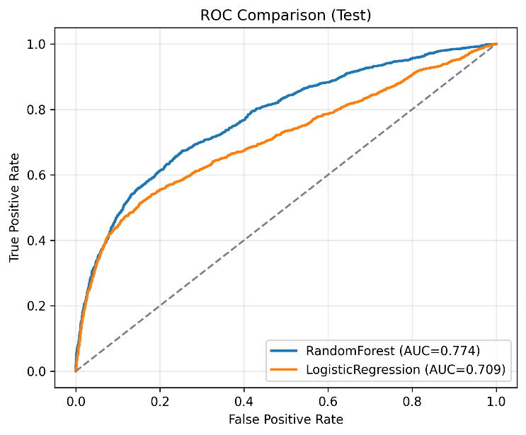
Figure 1 : ROC curves for Logistic Regression and Random Forest (test set).

  - Global Interpretability
To understand the dominant drivers of default risk, global interpretability analyses were conducted using Random Forest feature importance measures and SHAP summary statistics. Across these analyses, repayment status variables, particularly PAY_0 and PAY_2, emerge as the most influential predictors, followed by the credit limit feature LIMIT_BAL. This result is consistent with financial domain knowledge, as recent repayment behavior is a strong indicator of short-term default risk.
The relatively lower influence of demographic attributes indicates that the model primarily relies on behavioral and financial signals rather than static personal characteristics, which is desirable from both ethical and governance perspectives. Figure 2 shows the top features ranked by Random Forest Gini importance.

  - Local Interpretability
While global explanations describe population-level patterns, individual credit decisions require localized explanations to support auditing and regulatory review.

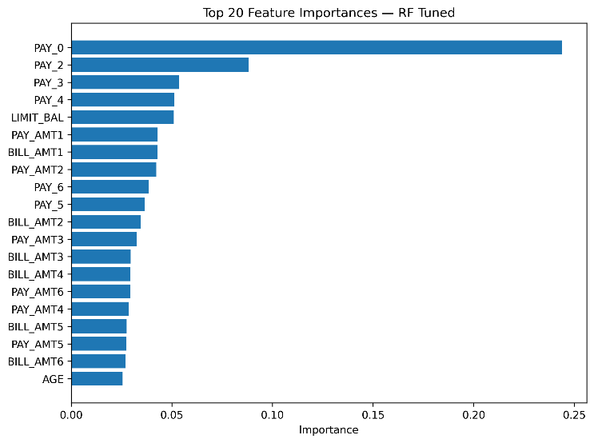
Figure 2: Top features by Random Forest Gini importance.
Local interpretability is examined using both SHAP and LIME explanations. Figure 3 presents a representative LIME explanation for a true-positive instance. In this example, delayed repayment behavior captured by PAY_0 and higher outstanding bill amounts such as BILL_AMT1 contribute positively to the predicted probability of default.
The consistency between SHAP-based attributions and LIME explanations strengthens confidence in the reliability of instance-level explanations. Such localized insights are critical for justifying adverse credit decisions and for providing transparent explanations to stakeholders.

  - PDP and ICE Analysis
To further analyze how individual features influence model predictions, Partial Dependence Plots and Individual Conditional Expectation plots are employed. Figure 4 illustrates the partial dependence of default probability on the repayment status feature PAY_0. The plot shows a sharp increase in predicted default risk once repayment delays exceed two months, indicating a non-linear escalation of risk.
ICE plots complement this analysis by revealing heterogeneity across individual observations. While the average effect highlights a clear risk threshold, individual curves demonstrate that sensitivity to repayment delays varies across clients, suggesting the presence of distinct risk subpopulations.
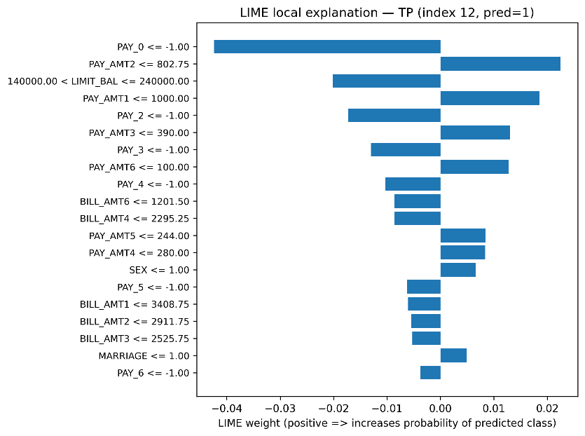
Figure 3: LIME local explanation for a true-positive prediction.
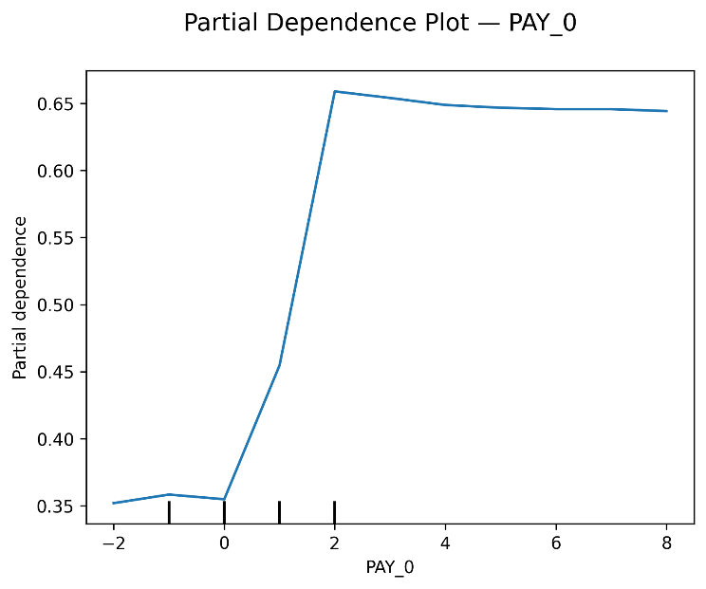
Figure 4: Partial Dependence Plot for PAY_0 on default probability.

  - Fairness and Calibration

Fairness and calibration diagnostics are essential for assessing model suitability in regulated financial environments. Fairness is evaluated by comparing recall across protected attributes, including sex and education level. The observed recall gap by sex is below 0.03, indicating relatively balanced performance across groups, as shown in Figure 5. While this does not eliminate the need for continuous monitoring, it suggests that the model does not exhibit strong group-level disparities in identifying defaulters.
Calibration analysis examines the alignment between predicted probabilities and observed default frequencies. The reliability diagram and Brier score indicate moderate overconfidence in the Random Forest model, a known characteristic of tree-based ensembles. This finding highlights the importance of calibration checks prior to deployment, particularly when predicted probabilities are used for downstream decisions such as risk pricing or credit limit assignment.
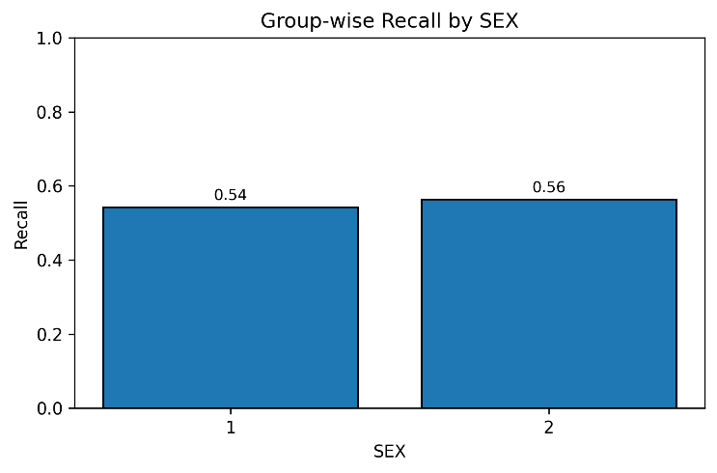
Figure 5: Recall by protected attribute (SEX).

  - UMAP Visualization
UMAP is employed to project the high-dimensional feature space of the test set into two dimensions to support qualitative inspection of model behavior. Figure 6 visualizes this projection, with each point representing an individual client and color intensity indicating the predicted probability of default.
Clear clustering patterns are observed, separating low-risk and high-risk cohorts. Clients with elevated predicted default probabilities tend to form compact regions, largely driven by shared repayment-delay characteristics and billing patterns. This visualization complements quantitative explainability results by offering an intuitive, cohort-level view of risk segmentation and helps identify structurally similar borrower groups for further investigation.

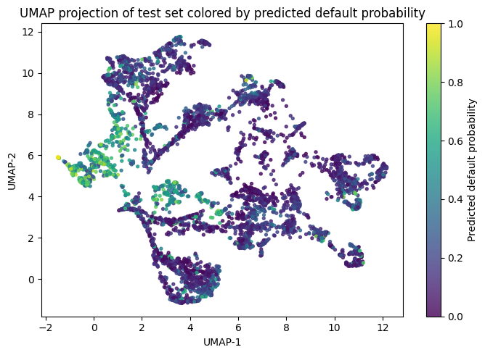
Figure 6 UMPS PROJECTION
Fig.6: UMAP projection of the test set colored by predicted default probability. Each point represents a client, with darker colors indicating higher predicted default risk. Distinct clusters highlight natural separation between low- and high-risk cohorts, supporting qualitative risk segmentation.

  - Operational Implications
The experimental results indicate that the proposed XAI pipeline can support practical credit decision-making by combining improved predictive performance with transparent model behavior. Compared to the logistic regression baseline, the Random Forest model provides stronger discrimination of high-risk clients, while layered explainability techniques enable both portfolio-level insights and case-by-case justification of individual decisions.
From an operational perspective, global explanations help risk teams identify key drivers of default, such as recent repayment delays and credit utilization, which can inform policy adjustments and portfolio monitoring. Local explanations generated through SHAP and LIME support audit requirements by providing clear, instance-level reasoning for adverse credit outcomes. In addition, calibration diagnostics highlight the need for probability adjustment prior to deployment, particularly when model outputs are used for threshold-based approvals, credit limit assignment, or risk pricing.
Fairness analysis further emphasizes the importance of continuous subgroup monitoring to detect potential disparities over time. Together, these components demonstrate that non-linear models can be responsibly integrated into production credit workflows when accompanied by systematic explainability, calibration, and fairness controls, enabling more informed, accountable, and regulator-ready financial decision systems.

  - Limitations
While the proposed framework demonstrates improved predictive performance and provides multiple layers of interpretability, several limitations should be acknowledged. First, all experiments are conducted on a single publicly available dataset, which may not fully represent the complexity and diversity of real-world credit portfolios. As a result, the generalization of the findings to other financial contexts requires further validation.
Second, the analysis is based on static customer records and does not account for temporal dynamics or concept drift, which are common in operational credit risk environments. Incorporating time-aware modeling and longitudinal evaluation could provide deeper insight into model stability over time.
Third, although SHAP and LIME offer useful post-hoc explanations, they describe model behavior rather than causal relationships. Therefore, the explanations should be interpreted as indicative patterns rather than definitive causes of default. Finally, fairness assessment in this study is limited to selected attributes and recall-based comparisons, and more comprehensive bias mitigation strategies remain an important direction for future work.

- Conclusion
This paper presented a reproducible Explainable AI pipeline for credit default prediction using the UCI Credit Card dataset. By combining an interpretable logistic regression baseline with a tuned Random Forest model, the study demonstrates that improved predictive performance can be achieved without sacrificing transparency. The Random Forest model attained a ROC-AUC of 0.7743 on the held-out test set, while layered explainability techniques enabled both global and instance-level understanding of model behavior.
Experimental results show that repayment history and credit utilization are the dominant drivers of default risk, aligning with established financial intuition. SHAP and LIME explanations provide practical case-level insights, while Partial Dependence, ICE, calibration analysis, fairness evaluation, and UMAP visualization offer complementary perspectives on model reliability and subgroup behavior. Together, these components support responsible deployment by addressing accuracy, interpretability, calibration, and fairness within a single framework.
The proposed approach highlights how non-linear machine learning models can be integrated into regulated financial decision systems when accompanied by systematic diagnostic and explainability controls. Future work will focus on extending the framework to temporal data, incorporating counterfactual explanations, and developing real-time monitoring tools to track model drift and fairness over time.

- References
- Hand, D., Mannila, H., Smyth, P.: Principles of Data Mining. MIT Press (2001)
- Yeh, I.-C., Lien, C.-H.: The comparisons of data mining techniques for the predictive accuracy of probability of default of credit card clients. Expert Systems with Applications 36(2), 2473–2480 (2009)
- Ribeiro, M.T., Singh, S., Guestrin, C.: “Why should I trust you?”: Explaining the predictions of any classifier. In: KDD, pp. 1135–1144 (2016)
- Lundberg, S.M., Lee, S.-I.: A unified approach to interpreting model predictions. In: NeurIPS, pp. 4765–4774 (2017)
- Guidotti, R., Monreale, A., Ruggieri, S., Turini, F., Giannotti, F., Pedreschi, D.: A survey of methods for explaining black box models. ACM Comput. Surv. 51(5), 1–42 (2018)
- Arrieta, A.B., Díaz-Rodríguez, N., Del Ser, J., et al.: Explainable Artificial Intelligence (XAI): Concepts, taxonomies, opportunities and challenges toward responsible AI. Information Fusion 58, 82–115 (2020)
- Bracke, P., et al.: Machine learning explainability in finance: An application to default risk analysis. Bank of England Staff Working Paper No. 816 (2019)
- Misheva, B.H., et al.: Explaining credit risk models using SHAP values. Journal of Risk Finance (2021). arXiv:2103.00949
- Gramegna, F., Giudici, P.: On the use of explainable AI for credit scoring: SHAP and LIME in practice. Applied Soft Computing (2021)
- Kozodoi, N., Lessmann, S., Vanoirbeek, C.: Fairness in credit scoring: Assessment, implementation and profit implications. Eur. J. Oper. Res. 297(3), 706–721 (2022)
- Friedman, J.H.: Greedy function approximation: A gradient boosting machine. Ann. Stat. 29(5), 1189–1232 (2001)
- Niculescu-Mizil, A., Caruana, R.: Predicting good probabilities with supervised learning. In: ICML, pp. 625–632 (2005)
- Molnar, C.: Interpretable Machine Learning. A Guide for Making Black Box Models Explainable. (2020)
- Wachter, S., Mittelstadt, B., Floridi, L.: Why a right to explanation of automated decision-making should exist. International Data Privacy Law 7(4), 241–256 (2017)
- McInnes, L., Healy, J., Melville, J.: UMAP: Uniform Manifold Approximation and Projection for dimension reduction. arXiv:1802.03426 (2018)
- European Union: Regulation (EU) 2024/1689 (Artificial Intelligence Act). Official Journal of the European Union (2024)
- Rudin, C (2019) : Stop explaining black box machine learning models for high‐stakes decisions and use interpretable models instead. Nature Machine Intelligence, 1(5), 206–215
- Doshi-Velez, F., & Kim, B.:Towards a rigorous science of interpretable machine learning (2017).

